INTERNATIONAL ORGANISATION FOR STANDARDISATION
ORGANISATION INTERNATIONALE DE NORMALISATION
ISO/IEC JTC 1/SC 29/WG 11
CODING OF MOVING PICTURES AND AUDIO

ISO/IEC JTC 1/SC 29/WG 11
MPEG2018/M43581
July 2018, Ljubljana, SI

Source:  Status: | Universidad Politécnica de Madrid and Huawei Technologies Co., Ltd.  Informative
Title:  Authors: | Results of FTV-Wei project: Real-time free-viewpoint videoconferencing system  Pablo Carballeira <pcl@gti.ssr.upm.es>, Daniel Berjón, Sergio Arnaldo, Carlos Carmona, Daniel Corregidor, Carmen Doblado, M. Mar Martín, Julián Cabrera, César Díaz, Francisco Morán, Narciso García (Universidad Politécnica de Madrid)  Huawei Technologies Co., Ltd.

Introduction
This contribution summarizes the results and main characteristics of the end-to-end free-viewpoint videoconferencing system developed within the FTV-Wei project. Our system works in real time, using off-the-shelf hardware, and texture and depth data captured by consumer-grade cameras. To achieve high visual quality with those restrictions, a novel view synthesis algorithm has been developed, including texture+depth processing tools to enhance the view synthesis quality. Coding and transmission are based on MPEG standards and well-established protocols.
In addition to this document, demo videos showing synthesis results and the real-time operation of the system will be presented at the meeting of the MPEG-I Visual AhG.

Overview of the FTV-Wei system
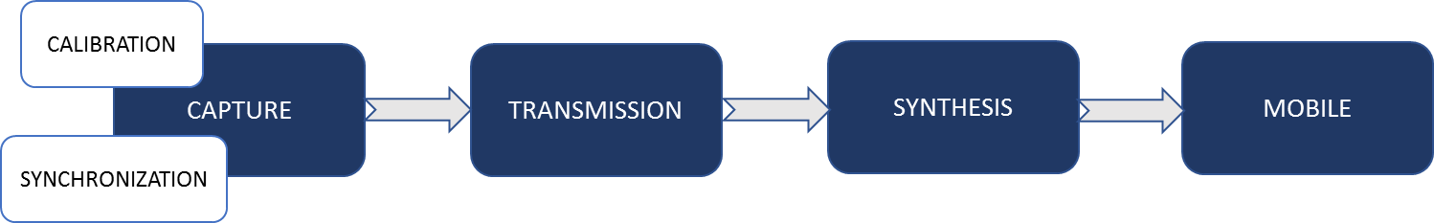
Figure 1: FTV-Wei system block scheme
Figure 1 shows the block scheme of the FTV-Wei system, that covers the end-to-end processing chain of (one direction of) a free-viewpoint videoconference. The scheme covers the whole process, from capture to the rendering of the virtual viewpoint, that is displayed in a mobile client, namely a Huawei Mate 9 smartphone. The user can control the virtual viewpoint of the scene, in real time, by swiping his/her finger on the smartphone display: see Figure 2.
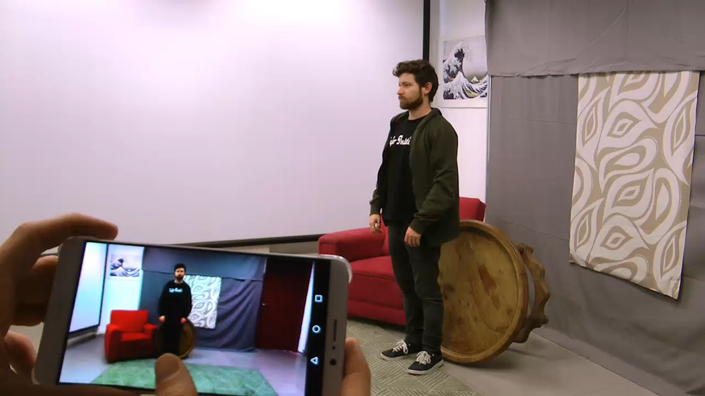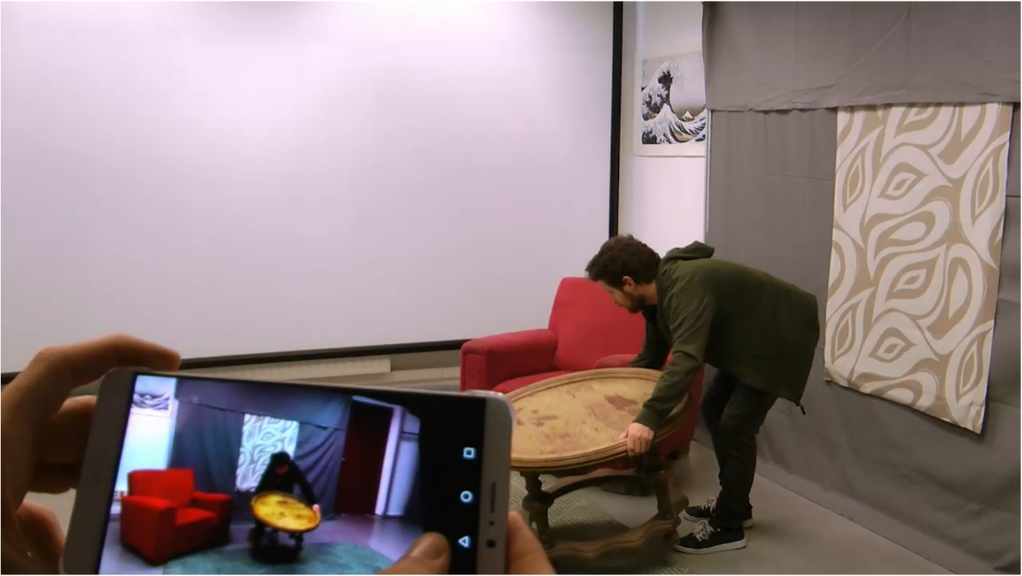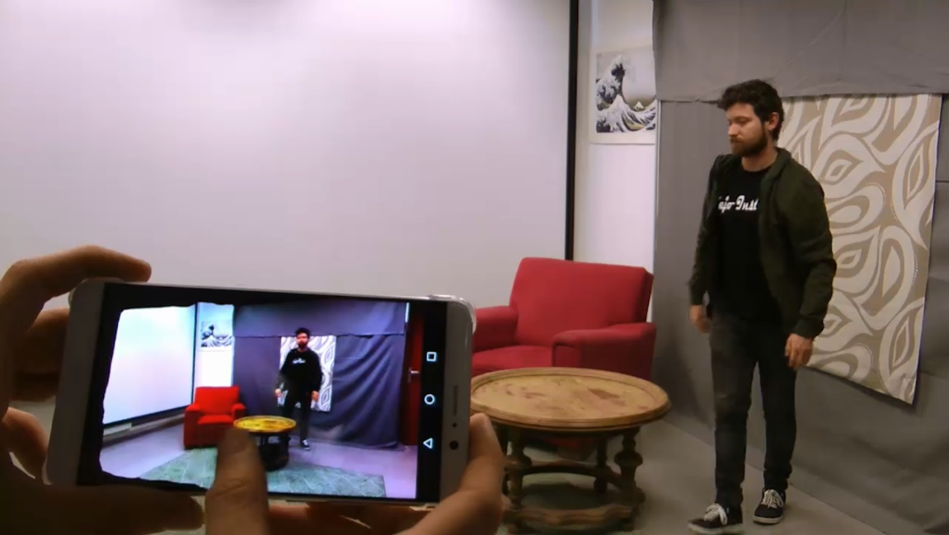
Figure 2: Three frames from a video capturing the virtual view displayed on the smartphone in front of the original scene, to show minimum end-to-end delay and the real-time user control of the virtual viewpoint by swiping a finger on the smartphone display. Top row: initial viewpoint located at approximately the center of the virtual view range; middle and bottom rows: viewpoint moved towards the left and right respectively
Table 1 shows an overview of the main technical characteristics and the hardware used in the current setting of the FTV-Wei system. This technical overview shows that the system can operate in real-time using off-the-shelf hardware.
Table 1 Overview of the capabilities and hardware of the FTV-Wei system
Technical characteristics
Resolution: | Full HD (1920x1080p)
Frame rate: | 30 fps
Total nr. of cameras: | 9
Motion-to-photon delay: | ~170 ms
End-to-end delay: | < 400 ms
Equipment
Capture server PCs (x3): | Intel Core i7-6850K @ 3.6 GHz + 64 GB RAM  + NVIDIA GEFORCE GTX 1080  + NVIDIA QUADRO P4000  + Stereolab ZED cameras (3x)
Synthesis server PC: | Same as above, except for the cameras
Client smartphone: | Huawei Mate 9

Capture and calibration
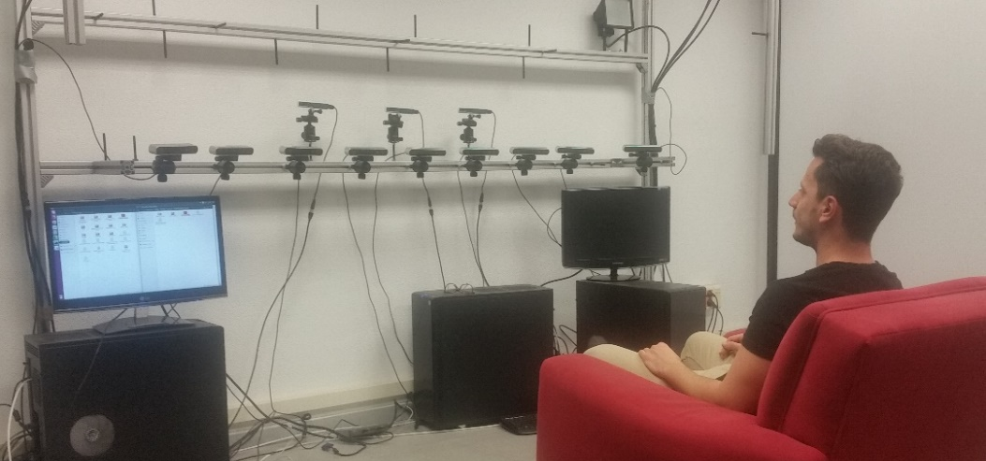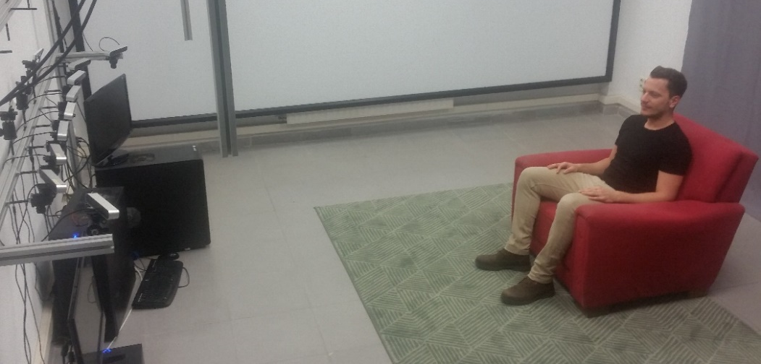
Figure 3: Camera setting for the FTV-Wei project and captured scene
Figure 3 shows the current setting of cameras and the scene captured at GTI-UPM facilities, where a room is currently exclusively devoted to the development and demonstration of the FTV-Wei system. The current multi-camera setting comprises 9 cameras, which can be re-configured and re-calibrated using standard multi-view calibration procedures based on checkerboard patterns (Figure 4).
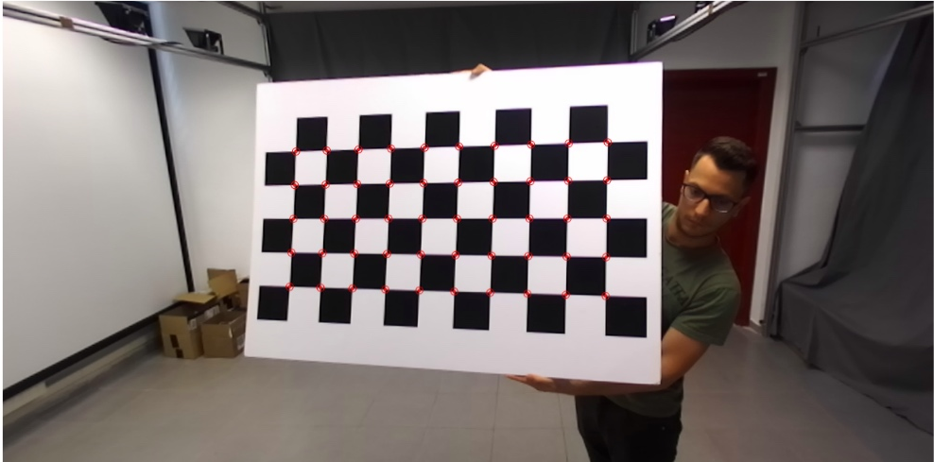
Figure 4: Multi-camera calibration using checkerboard patterns

Coding and transmission
The compression of texture and geometry (depth) data is performed using standard MPEG compression schemes. The transmission of the compressed RGB+depth data from the capture servers to the synthesis server is handled by standard transmission protocols.

View synthesis
The view synthesis algorithm has been designed and implemented to work at full HD in real time (1920x1080p@30fps), while providing high-quality synthesis results from RGB+depth data yielded by consumer-grade cameras. To fulfill these two requirements, the view synthesis algorithm follows a novel scheme and includes several RGB+depth processing tools that cannot be disclosed yet.
Examples of the view synthesis results will be demonstrated at the presentation of the contribution at the MPEG-I Visual AhG, to prove that the view synthesis module of the FTV-Wei project outperforms MPEG’s View Synthesis Reference Software (VSRS) [1] in terms of subjective quality.

Conclusions
This contribution informs about the finalization of the FTV-Wei project, developed in collaboration between UPM and Huawei. This project demonstrates the interest of industrial partners in free-viewpoint video systems (windowed-6DoF) and encourages MPEG to continue related standardization activities.

References
- ISO/IEC JTC 1/SC 29/WG 11 output doc. N17548, “Exploration Experiments for MPEG-I: Windowed-6DoF”, 122nd MPEG meeting, San Diego, US, April 2018.

